Grove - Water Sensor

(Redirected from [Twig - Water Sensor](http://www.seeedstudio.com/wiki/index.php?title=Twig_-_Water_Sensor&redirect=no))

|  |
| --- |
| **Contents**   [[hide](javascript:toggleToc())]   * [1 Introduction](http://www.seeedstudio.com/wiki/index.php?title=Twig_-_Water_Sensor#Introduction) * [2 Features](http://www.seeedstudio.com/wiki/index.php?title=Twig_-_Water_Sensor#Features) * [3 Applications Ideas](http://www.seeedstudio.com/wiki/index.php?title=Twig_-_Water_Sensor#Applications_Ideas) * [4 Cautions](http://www.seeedstudio.com/wiki/index.php?title=Twig_-_Water_Sensor#Cautions) * [5 Specification](http://www.seeedstudio.com/wiki/index.php?title=Twig_-_Water_Sensor#Specification) * [6 Usage](http://www.seeedstudio.com/wiki/index.php?title=Twig_-_Water_Sensor#Usage) * [7 Resources](http://www.seeedstudio.com/wiki/index.php?title=Twig_-_Water_Sensor#Resources) * [8 Support](http://www.seeedstudio.com/wiki/index.php?title=Twig_-_Water_Sensor#Support) |

Introduction

The Water Sensor module is part of the Grove system. It measures conductivity and indicates whether the sensor is dry, damp or completely immersed in water. The sensor traces have a weak pull-up resistor of 1 MΩ. The resistor will pull the sensor trace value high until a drop of water shorts the sensor trace to the grounded trace. Believe it or not this circuit will work with the digital I/O pins of your Arduino or you can use it with the analog pins to detect the amount of water induced contact between the grounded and sensor traces.

Model:[SEN113104](http://www.seeedstudio.com/depot/twig-water-sensor-p-748.html?cPath=144_151)

[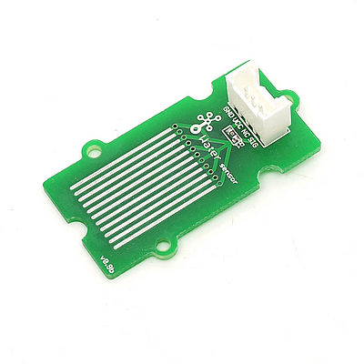](http://www.seeedstudio.com/wiki/File:Twig_-_Water_Sensor.jpg)

Features

* Grove compatible interface
* Low power consumption
* 2.0cm x 2.0cm Grove module
* High sensitivity

Applications Ideas

* Rainfall detecting
* Liquid leakage
* Tank overflow detector

Cautions

This device is for educational and hobby applications only. It is not intended to be used in applications where its malfunction could result in damage to property or human safety.

Specification

|  |  |  |  |  |
| --- | --- | --- | --- | --- |
| **Item** | **Min** | **Typical** | **Max** | **Unit** |
| **Working Voltage** | 4.75 | 5.0 | 5.25 | V |
| **Current** | <20 | | | mA |
| **Working Temperature** | 10 | - | 30 | ℃ |
| **Working Humidity (without condensation)** | 10 | - | 90 | % |
| **2.4*4.2CM** |  |  |  |  |

Usage

Connect the module to the Basic board using any of the digital pin. You can gain the value of the signal pin. When there is water on the bare conducting wires, the value is LOW. Else it is HIGH.

The following sketch demonstrates a simple application of using the Water sensor to control the buzzer. As the picture on the below indicates, the Water sensor is connected to digital port 8 of the [Grove - Basic Shield](http://www.seeedstudio.com/wiki/Grove_-_Base_Shield) and the Buzzer is connected to digital port 12. When there is water on the bare conducting wires, the SIG pin output a LOW voltage. Then the Buzzer sounds. The hardware installation is as follows:

[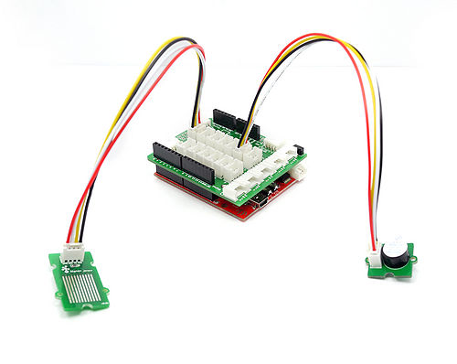](http://www.seeedstudio.com/wiki/File:Water_Buzzer.jpg)  
Then connect Arduino to PC by using a USB cable.   
Copy and paste code below to a new Arduino sketch.

/*macro definition of water sensor and the buzzer*/

#define WATER_SENSOR 8

#define BUZZER 12

void setup()

{

pins_init();

}

void loop()

{

if(isExposedToWater())

soundAlarm();

}

void pins_init()

{

pinMode(WATER_SENSOR, INPUT);

pinMode(BUZZER, OUTPUT);

}

/************************************************************************/

/*Function: When the sensor is exposed to the water, the buzzer sounds */

/* for 2 seonds. */

void soundAlarm()

{

for(uint8_t i = 0;i < 20;i ++)

{

digitalWrite(BUZZER, HIGH);

delay(50);

digitalWrite(BUZZER, LOW);

delay(50);

}

}

/************************************************************************/

/*Function: Determine whether the sensor is exposed to the water */

/*Parameter:-void */

/*Return: -boolean,if it is exposed to the water,it will return ture. */

boolean isExposedToWater()

{

if(digitalRead(WATER_SENSOR) == LOW)

return true;

else return false;

}

Upload the code, Please click [here](http://www.seeedstudio.com/wiki/Upload_Code) if you do not know how to upload.  
Then the buzzer sounds when the sensor is damp or completely immersed in water. Have a try!

Resources

* [Water Sensor Eagle Files](http://garden.seeedstudio.com/images/9/95/Water_sensor.zip)